**Eritrea country profile**

Published

15 November 2018

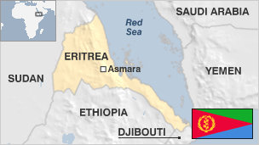

**Eritrea won independence from Ethiopia in 1993 after a 30-year war, but has been plagued by repression at home and tense relations with its neighbours.**

Bordered by Sudan, Ethiopia and Djibouti, it occupies a strategically important area in the Horn of Africa.

Tensions remained high across the closed and heavily-fortified border until 2018, when Ethiopia launched a surprise diplomatic initiative that formally ended the state of war between the two countries.

Eritrea is a one-party state and a highly-militarised society, which the government has sought to justify by citing the threat of war with Ethiopia.

Prolonged periods of conflict and severe drought have adversely affected Eritrea's agricultural economy, and it remains one of the poorest countries in Africa.

By UN estimates, hundreds of thousands of Eritreans have fled the country in recent years, making the perilous journey across the Sahara and the Mediterranean to Europe.

* Read more [country profiles](http://news.bbc.co.uk/1/hi/country_profiles/) - Profiles by [BBC Monitoring](http://bbc.co.uk/monitoring)

**President: Isaias Afwerki**

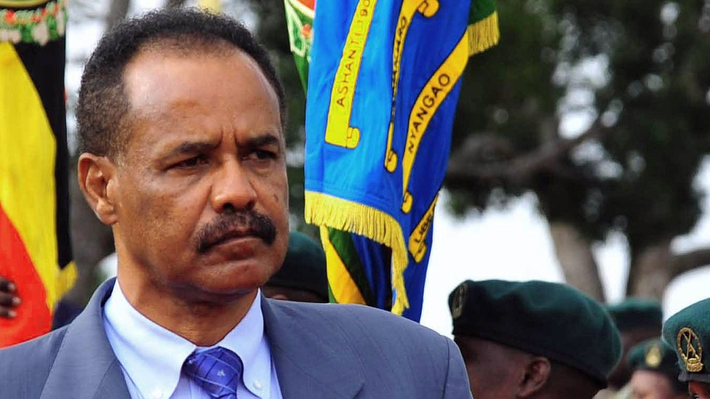image copyrightGetty Images

President Isaias Afwerki has governed Eritrea since it became an independent country in 1993. His People's Front for Democracy and Justice (PFDF) is the sole political party.

Presidential elections planned for 1997 never took place, and a constitution ratified in the same year has never been implemented.

In 1966 he joined the fight for independence from Ethiopia, and went on to found and later lead the Eritrean People's Liberation Front. He became head of the provisional government in 1991, when the Front defeated the forces of the Marxist Ethiopian government.

Following the 1993 referendum vote for independence, he was elected president and chairman of parliament, giving him control of both the executive and legislative branches of government.

Media beyond the state-sanctioned newspapers and broadcasters are non-existent.

Outlets run by Eritreans overseas provide alternative sources of news but their reach is limited, not least because of very low levels of internet access.

# Eritrea profile - Timeline

Published

15 November 2018

**A chronology of key events:**

**300-600** - What is now known as Eritrea forms part of the kingdom of Aksum.

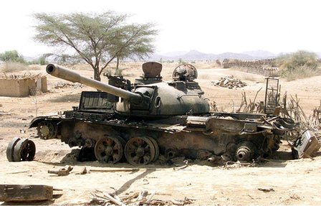image copyrightGetty Images

image captionThe border war between Eritrea and Ethiopia between 1998 and 2000 killed thousands of people

**600** - Arabs introduce Islam to coastal areas.

**1500s** - Ottoman Turks establish garrison at Massawa on the Red Sea coast.

**1890** - Italy proclaims colony of Eritrea.

**1941** - British forces occupy Eritrea.

**1949** - Britain administers Eritrea as a United Nations trust territory.

**1952** - UN General Assembly votes to make Eritrea a federal component of Ethiopia.

**1958** - Eritrean Liberation Front (ELF) is formed.

**Independence war**

**1962** - Ethiopia annexes Eritrea, turning it into a province and giving impetus to the independence struggle.

**1967** - Full-scale guerrilla war is under way.

**1970** - ELF splits and the Eritrean People's Liberation Front (EPLF) is formed, calling for a social revolution.

**1974** - Ethiopian Emperor Haile Selassie is overthrown in a military coup. A military junta led by Mengistu Haile Mariam seizes power.

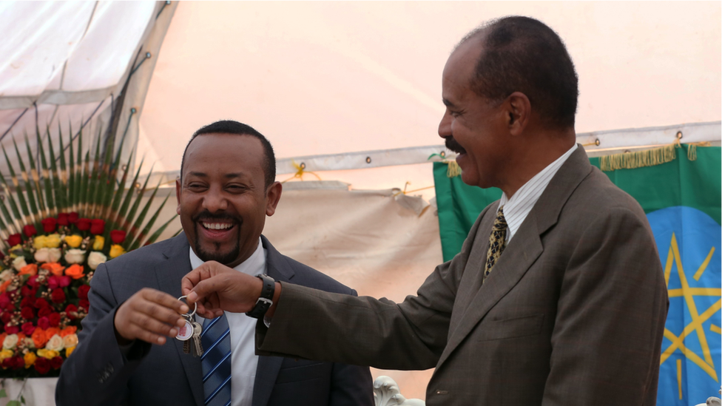image copyrightMinasse Wondimu Hailu/Anadolu Agency/Getty Images

image captionPresident Isaias Afwerki (right) was in Addis Ababa for the inauguration of the Eritrean embassy in July 2018

**1977-78** - Soviet support helps Ethiopian forces reverse significant advances made by Eritrean guerrillas.

**1982** - Ethiopia launches a massive military assault named the Red Star Campaign in an effort to crush the rebels but suffers heavy casualties.

**1991** - Eritrean People's Liberation Front captures the Eritrean capital Asmara and forms a provisional government. The EPLF helps its allies in the Ethiopian rebel movement to topple Mengistu Haile Mariam.

## Independence

**1993** - Eritreans vote overwhelmingly for independence.

**1998-2000** - Eritrean-Ethiopian border clashes turn into a full-scale war which leaves some 70,000 people dead.

**2007** - Eritrea pulls out of regional body IGAD (Intergovernmental Authority on Development) as IGAD member states back Ethiopian intervention in Somalia.

**2008** June - Fighting breaks out between Djiboutian and Eritrean troops in the disputed Ras Doumeira border area. At least nine Djiboutian soldiers killed. US condemns Eritrea, but Eritrea denies launching an attack.

**2009** December - UN imposes sanctions on Eritrea for its alleged support for Islamist insurgents in Somalia.

**2010** June - Eritrea, Djibouti agree to resolve their border dispute peacefully.

**2014** June - The UN Human Rights Council says about six per cent of the population has fled the country over repression and poverty

**2016** July - The UN Human Rights Council calls on the African Union to investigate Eritrean leaders for alleged crimes against humanity.

**2017** July - UNESCO adds Asmara to its list of World Heritage sites, describing it as a well-preserved example of a colonial planned city.

## Peace with Ethiopia

**2018** July - Ethiopia and Eritrea end state of war after Ethiopian diplomatic overtures.

**2018** November - UN Security Council ends nine years of sanctions on Eritrea, imposed over allegations of support for al-Shabab jihadists in Somalia.